TASK 01
#include <iostream>
using namespace std;

class BSTNode {
public:
int ISBN;
string name;
BSTNode* left;
BSTNode* right;

BSTNode(int ISBN, string name) : ISBN(ISBN), name(name), left(nullptr), right(nullptr) {}
};

class Library {
private:
BSTNode* root;

public:
Library() : root(nullptr) {}

BSTNode* getRoot () {
return root;
}

void insert(int ISBN, string name) {
if (root == nullptr) {
root = new BSTNode(ISBN, name);
return;
}
BSTNode* curr = root;
BSTNode* parent = nullptr;
while (curr != nullptr) {
parent = curr;
if (ISBN < curr->ISBN) {
curr = curr->left;
} else if (ISBN > curr->ISBN) {
curr = curr->right;
}
}
if (ISBN < parent->ISBN) {
parent->left = new BSTNode(ISBN, name);
} else {
parent->right = new BSTNode(ISBN, name);
}
}

void printPreOrder(BSTNode* node){
if (node != nullptr) {
cout << "ISBN: " << node->ISBN << ", name: " << node->name << endl;
printPreOrder(node->left);
printPreOrder(node->right);
}
}

void printInOrder(BSTNode* node) {
if (node != nullptr) {
printInOrder(node->left);
cout << "ISBN: " << node->ISBN << ", name: " << node->name << endl;
printInOrder(node->right);
}
}

void printPostOrder(BSTNode* node) {
if (node != nullptr) {
printPostOrder(node->left);
printPostOrder(node->right);
cout << "ISBN: " << node->ISBN << ", name: " << node->name << endl;
}
}
};
int main() {
Library lib;
lib.insert(10, "Harry Potter & the Philosopher's Stone");
lib.insert(5, "Guliver's Travels");
lib.insert(15, "Wuthering Heights");
lib.insert(3, "Oliver Twist");

cout << "\nIn-order Traversal:" << endl;
lib.printInOrder(lib.getRoot());
cout << "Pre-order Traversal:" << endl;
lib.printPreOrder(lib.getRoot());
cout << "\nPost-order Traversal:" << endl;
lib.printPostOrder(lib.getRoot());

return 0;
}

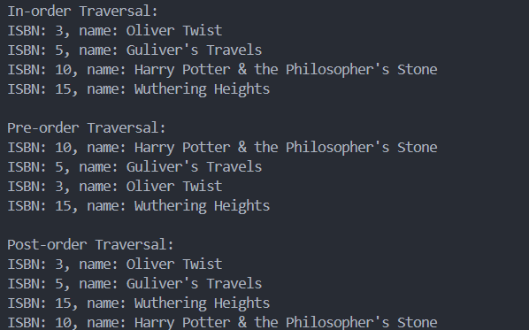
TASK 02
#include <iostream>
using namespace std;

class BSTNode {
public:
int data;
string info;
BSTNode* left;
BSTNode* right;

BSTNode(int data, string info) : data(data), info(info), left(nullptr), right(nullptr) {}
};

class CustomerInfo {
private:
BSTNode* root;

public:
CustomerInfo() : root(nullptr) {}

BSTNode* getRoot () {
return root;
}

void insert(int data, string info) {
if (root == nullptr) {
root = new BSTNode(data, info);
return;
}
BSTNode* curr = root;
BSTNode* parent = nullptr;
while (curr != nullptr) {
parent = curr;
if (data < curr->data) {
curr = curr->left;
} else if (data > curr->data) {
curr = curr->right;
} else {
return;
}
}
if (data < parent->data) {
parent->left = new BSTNode(data, info);
} else {
parent->right = new BSTNode(data, info);
}
}

void printInOrder(BSTNode* node) {
BSTNode* stack[100];
int top = -1;
BSTNode* curr = node;
while (curr != nullptr || top != -1) {
while (curr != nullptr) {
stack[++top] = curr;
curr = curr->left;
}
curr = stack[top--];
cout << "data: " << curr->data << ", info: " << curr->info << endl;
curr = curr->right;
}
}

void printPreOrder(BSTNode* node) {
if (!node) return;
BSTNode* stack[100];
int top = -1;
stack[++top] = node;
while (top != -1) {
BSTNode* curr = stack[top--];
cout << "data: " << curr->data << ", info: " << curr->info << endl;
if (curr->right) stack[++top] = curr->right;
if (curr->left) stack[++top] = curr->left;
}
}

void printPostOrder(BSTNode* node) {
if (!node) return;
BSTNode* stack[100];
int top = -1;
BSTNode* out[100];
int outTop = -1;
stack[++top] = node;
while (top != -1) {
BSTNode* curr = stack[top--];
out[++outTop] = curr;
if (curr->left) stack[++top] = curr->left;
if (curr->right) stack[++top] = curr->right;
}
while (outTop != -1) {
BSTNode* curr = out[outTop--];
cout << "data: " << curr->data << ", info: " << curr->info << endl;
}
}
};

int main() {
CustomerInfo lib;
lib.insert(5, "Harry");
lib.insert(3, "Ron");
lib.insert(7, "Hermione");
lib.insert(2, "Draco");
lib.insert(4, "Luna");
cout << "InOrder Traversal:" << endl;
lib.printInOrder(lib.getRoot());
cout << "PreOrder Traversal:" << endl;
lib.printPreOrder(lib.getRoot());
cout << "PostOrder Traversal:" << endl;
lib.printPostOrder(lib.getRoot());

return 0;
}

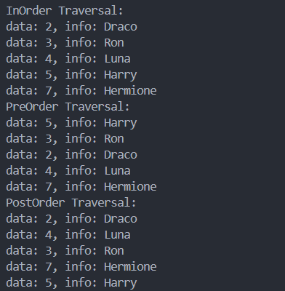
TASK 04 (redone with a linear queue)
#include <iostream>
using namespace std;

#define N 20

class Queue {
int front, rear;
int arr[N];

public:
Queue() : front(-1), rear(-1) {}

bool isEmpty() {
return (front == -1 || front > rear);
}

bool isFull() {
return (rear == N - 1);
}

void enqueue(int x) {
if (isFull()) {
cout << "Queue Overflow" << endl;
}
if (front == -1) {
front = 0;
}
arr[++rear] = x;
cout << x << " enqueued to queue" << endl;
}

int dequeue() {
if (isEmpty()) {
cout << "Queue Underflow" << endl;
return 0;
}
cout << arr[front] << " dequeued from queue" << endl;
return arr[front++];
}

int peek() {
if (isEmpty()) {
cout << "Queue is empty" << endl;
return 0;
}
return arr[front];
}
};

int main() {
Queue q;
q.enqueue(101);
q.enqueue(102);
q.enqueue(103);
q.enqueue(104);

cout << "Peeked at the first value: " << q.peek() << endl;
q.dequeue();
cout << "Peeked at the first value: " << q.peek() << endl;

return 0;
}

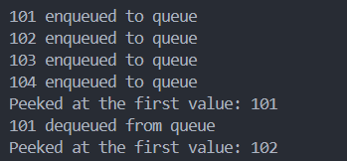
TASK 05
#include <iostream>
using namespace std;

#define N 5

class SongsQueue {
int front, rear;
string arr[N];

public:
SongsQueue() : front(-1), rear(-1) {}

bool isEmpty() {
return (front == -1 && rear == -1);
}

bool isFull() {
return ((rear + 1) % N == front);
}

void addSong(string x) {
if (isFull()) {
front = (front + 1) % N;
rear = (rear + 1) % N;
arr[rear] = x;
cout << "Queue Full. Overwriting oldest song with: " << x << endl;
} else {
if (isEmpty()) {
front = rear = 0;
} else {
rear = (rear + 1) % N;
}
arr[rear] = x;
cout << "Added to queue: " << x << endl;
}
displayPlaylist();
}

string playNext() {
if (isEmpty()) {
cout << "No songs in the queue" << endl;
return "";
}
string x = arr[front];
cout << "Skipped: " << x << endl;
if (front == rear) {
front = rear = -1;
} else {
front = (front + 1) % N;
}
displayPlaylist();
return x;
}

string seeCurrent() {
if (isEmpty()) {
cout << "No songs in the queue" << endl;
return "";
} else {
return arr[front];
}
}

void displayPlaylist() {
cout << "Current Playlist: ";
if (isEmpty()) {
cout << "No songs in the queue" << endl;
return;
}
int i = front;
while (true) {
cout << arr[i];
if (i == rear) break;
cout << " | ";
i = (i + 1) % N;
}
cout << endl << endl;
}
};

int main() {
SongsQueue s;
s.addSong("The World Smallest Violin");
s.addSong("Believer");
s.addSong("Viva La Vida");
s.addSong("As It Was");
s.addSong("Thunder");
s.addSong("Counting Stars");

cout << "Now playing: " << s.seeCurrent() << endl;
s.playNext();
cout << "Now Playing: " << s.seeCurrent() << endl;

return 0;
}

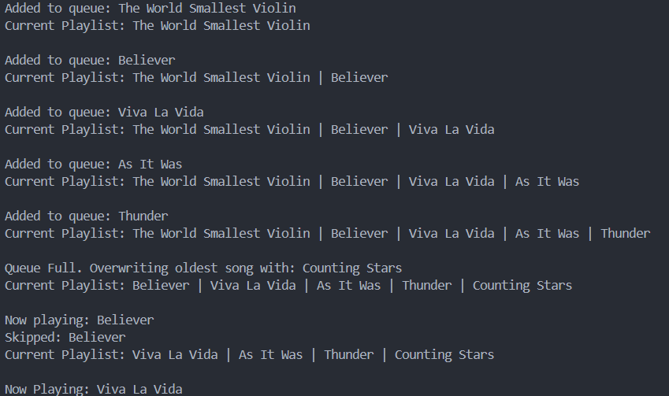
TASK 06
#include <iostream>
using namespace std;

class BTNode {
public:
int data;
BTNode* left;
BTNode* right;

BTNode(int data) : data(data), left(nullptr), right(nullptr) {}
};

class CompleteBT {
public:
BTNode* root;

CompleteBT() : root(nullptr) {}

BTNode* getRoot () {
return root;
}

void insert(BTNode* &root, int val) {
if (root == nullptr) {
root = new BTNode(val);
return;
}
BTNode* arr[100]; // assume a maximum of 100 nodes
int front = 0, rear = 0;
arr[rear++] = root;
while (front < rear) {
BTNode* curr = arr[front++];
if (curr->left == nullptr) {
curr->left = new BTNode(val);
return;
} else {
arr[rear++] = curr->left;
}
if (curr->right == nullptr) {
curr->right = new BTNode(val);
return;
} else {
arr[rear++] = curr->right;
}
}
}

void printLevelOrder(BTNode* root) {
if (!root) return;
BTNode* arr[100];
int front = 0, rear = 0;
arr[rear++] = root;
while (front < rear) {
BTNode* curr = arr[front++];
cout << curr->data << " ";
if (curr->left) arr[rear++] = curr->left;
if (curr->right) arr[rear++] = curr->right;
}
cout << endl;
}
};

int main() {
CompleteBT tree;
tree.insert(tree.root, 1);
tree.insert(tree.root, 2);
tree.insert(tree.root, 3);
tree.insert(tree.root, 4);
tree.insert(tree.root, 5);

cout << "Before insertion: ";
tree.printLevelOrder(tree.root);

tree.insert(tree.root, 6);

cout << "After insertion: ";
tree.printLevelOrder(tree.root);

return 0;
}

